CLINICAL AND PATHOGENETIC SUBSTANTIATION OF EFFECTIVENESS OF ESSENTIALLE N AND GLUTARGIN COMBINATION IN TREATMENT OF CHRONIC ABDOMINAL ISCHEMIC SYNDROME
N. B. Gubergrits, N. G. Agapova, L. I. Shkarbun
Donetsk National Medical University n. a. M. Gorky, Ukraine

There are no rare diseases, but rare diagnoses
S. A. Reinberg,
noted radiologist

Key words: abdominal ischemic syndrome, sonography of abdominal aorta, liver and pancreas, Doppler ultrasonography, Essentiale N, Glutargin
Abdominal ischemic syndrome (AIS) is one of the rarest diagnoses in internal medicine, but it is not a rare disease. Atherosclerosis of the abdominal aorta and its branches is revealed in 75.5% cases of autopsy deaths from coronary heart disease, hypertension, atherosclerosis of the cerebral arteries, the arteries of the lower extremities and their complications [20]. It means that AIS diagnostics is not carried out, despite the possibility of use in clinical practice not only invasive (angiography), but also non-invasive (Dopplerography) techniques. One of the main reasons for this situation is represented by non-specific clinical manifestations of the disease, lack of knowledge of doctors about it. In this regard, the relevant research methods are not prescribed, correct diagnosis is not set out, so the treatment is ineffective. Another consequence of the lack of AIS diagnosis is that more than half of the cases are diagnosed only upon the development of acute mesenteric circulation disorders, i.e. upon severe disorder. In earlier stages, when AIS should be treated to prevent acute surgical intervention, diagnostics is not performed. Thus, the problems of AIS diagnostics and treatment are both important scientific and practical tasks.
AIS ​​or its synonyms don’t have a cipher in ICD-10; own ciphers are registered only for aortic atherosclerosis (I 70.0), abdominal aortic aneurysm without mention of rupture (I 71.4), embolism and thrombosis of the abdominal aorta (I 74.0), celiac trunk compression syndrome of the abdominal aorta (I 77.4), vascular disease of the intestine (K 55.0 ― acute vascular disease of the intestine; K 55.1 ― chronic vascular disease of the intestine; K 55.2 ― angiodysplasia of the colon; K 55.8 ― other vascular diseases of the intestine; K 55.9 ― unspecified vascular disease of the intestine).
Upon AIS, blood flow is disturbed in the abdominal aorta and/or in its unpaired visceral branches, the first of which is the celiac trunk (splenic, common hepatic and left gastric artery are branching off from it), the second ― the top, and the third ― the inferior mesenteric artery.
AIS causes are divided into organic, functional and mixed ones. Organic causes, in their turn, are divided into extravascular compression (congenital and acquired), malformations of visceral arteries and visceral artery disease [20].
Congenital compression factors are the anomalies of divergence and position of visceral branches, pressure of falciform ligament or medial diaphragm crura (celiac trunk is located between these crura), elements (ganglia) of solar plexus [20].
Acquired compression factors include tumors, abdominal aortic aneurysm, periarterial or retroperitoneal fibrosis, adhesive process, pressure of the enlarged adjacent organs (e.g., head of the pancreas as it increases) [16, 17, 20, 34].
Malformations of the visceral branches leading to AIS: aplasia or hypoplasia of the arteries, fibromuscular dysplasia, congenital hemangiomas and fistulas [13, 20, 35].
Such artery diseases as atherosclerosis, non-specific aortoarteritis, post-traumatic aneurysms and arteriovenous fistulas, arteritis lead to AIS development [20, 23, 34].
Factors causing extravascular compression of the arteries are called extravasal; they cause AIS in 10-38% cases. The main etiological factors (diseases, developmental abnormalities and the arteries placement) are believed to beintravasal; they cause AIS in 62-90% cases. Moreover, atherosclerosis is the most common AIS cause (in 52.2-88.3% cases) [20, 22, 23, 28, 29].
Violation of the rheological properties of blood and coagulation, dyslipidemia (especially type IIA), intensification of lipid peroxidation (LPO) are involved in AIS pathogenesis [20].
There are 4 stages in AIS pathogenesis [27]. The first stage includes the main contributing factors to the development of organ and tissue ischemia, abnormalities in mitochondrial respiratory chain, catecholamines excess. The second stage is a stage of development of ATP deficiency, inhibiting the tricarboxylic acid cycle, glycolysis, ATP-dependent cation pumps and storage of fatty acids; as a result, significant changes in the lipid bilayer of cell membranes are formed. The third stage is a formation of the "lipid triad" (activation of lipases, phospholipases + activation of the detergent effect of excessive fatty acids and lysophospholipids on the membranes + LPO activation) . Fourth stage is a necrobiosis of cells and tissues.
AIS leads to the morphological and functional disorders of abdominal organs, it being known that upon intravasal etiology (atherosclerosis) changes are usually more evidential than upon the extravasal one. This is explained by the fact that several arterial beds are simultaneously affected in atherosclerosis [20].
Attention is attracted to the high frequency of erosive and ulcerative gastroduodenal mucosal changes in AIS patients, predominantly with affected gastric mucosa in the antrum and in the lesser curvature. Thus, upon AIS gastric ulcers are detected in 44.0% cases, duodenal ulcers ― in 24.8% cases, both gastric and duodenal ulcers ― in 11.1% cases, erosion of antral stomach ― in 16.5% cases, erosion in the duodenal bulb ― in 4.6% cases. Helicobacter pylori is rarely detected ― only in one third of the patients [20]. Such frequent erosive and ulcerative changes explain the decline in production and changes in the qualitative composition of the gastric mucosa, impaired alkalizing function of the antrum [20, 27]. Progressive atrophy of the gastric mucosa, mainly in the antrum, which is connected with the peculiarities of vascularity and sensitivity to hypoxia, is the predominant histological AIS feature [20, 27]. Hypoacidity is detected in 78.9% of AIS patients, violation of the motor and evacuation function of the stomach ― 67.8% [20].
Pancreatic functional insufficiency (reduced exo- and endocrine functions) is gradually increasing upon chronic ischemic pancreatic lesion, with proliferation of connective tissue within the lobules and between them, around the vessels and ducts lipoidosis, atrophy of acini with their replacement by connective and adipose tissue are the most frequent morphological changes [20]. Atherosclerosis of the abdominal aorta and celiac trunk can induce calcification of the pancreas.
Upon puncture liver biopsy in AIS patients, fatty steatosis (usually globular steatosis), perihepatotcellular, periportal and central fibrosis, ballooning degeneration of hepatocytes, moderate portal (periportal) hepatitis are detected in the overwhelming majority of cases. Frequency of fatty degeneration of hepatocytes is caused by hyper- and dyslipidemia in patients with atherosclerosis as AIS cause, as well as liver hypoxia itself. Some patients are determined to have ALT, AST, alkaline phosphatase increased by 1.5-2 times. There is hyperbilirubinemia (down to 30 mmol/L) in 21.7% cases. Protein-synthetic liver function is reduced upon severe AIS course (decreased albumin, prothrombin, fibrinogen indices) [20].
Ischemia of the small intestine and colon may promote their infarction and gangrene with necrosis spreading to all the layers of intestine. Upon transient disorders ("disappearing colitis syndrome"), morphological changes apply only to the surface layers of intestinal mucosa (ulceration, atrophy and destruction foci) [15, 23]. Chronic AIS option is characterized by the following morphological changes of small intestinal mucosa [20, 22, 29]:
- atrophy of the villi and crypts;
- reducing number of the crypts;
- reducing number of the goblet cells;
- presence of «hypoporiform» crypts and convoluted villi or irregular low villi, mucosal areas with villous lack and crypts atrophy.
As a result, malabsorption with weight loss up to cachexia, diarrhea, steatorrhea is being developed in 15.0% cases. The most important following morphological features of ischemic colitis are [20]:
- frequent localization in the splenic flexure;
- superficial mucosal necrosis with preservation of crypt epithelium over a large area;
- presence of thrombus or fibrin clots in the small arteries;
- macrophages loaded with hemosiderin;
- replacement of own muscular plate with connective tissue.
Colon motility suffers in ischemic colitis: the passage content becomes slower, with the development of constipation, flatulence. Formation of segmental stenosis, strictures of the colon is possible [15].
There are three stages of AIS course: compensation stage (clinical manifestations are absent), subcompensation (symptoms appear upon intaking large amounts of food), decompensation (symptoms are constant, getting worse after eating small amounts of food) [31].
Classic clinical AIS manifestations consist of three symptoms: abdominal pain, bowel dysfunction and weight loss [1, 15, 20, 23].
Let’s stop on the peculiarities of the ischemic lesion clinical manifestations of certain organs of the abdominal cavity.
Ischemic gastroduodenopathy is characterized by manifestation in the form of gastrointestinal bleeding, the lack of seasonal exacerbations in the case ulceration. Ulcers are often giant (diameter bigger than 3 cm), long-term cicatrizing [34].
Upon ischemic pancreatopathy, pain is localized in the epigastrium and left upper quadrant, occurs after eating and has a longer duration (a few hours). In contrast to chronic pancreatitis of banal etiology (alcoholic, biliary, etc.) upon ischemic pancreatopathy, as in other AIS forms, pain depends on the amount of the ingested food and not on its nature. In this regard, patients intake food in small fractional portions, as it was said above, sitophobia often is developed. More complex relationships occur when celiac artery lesions combine with inflammatory diseases of the pancreas. On the one hand, circulatory disorders can cause ischemic pancreatopathy, on the other ― due to the anatomical proximity of the pancreas and the celiac trunk, the latter can be secondarily involved in the inflammatory process, such as upon acute pancreatitis [4, 9, 34].
Symptoms of ischemic hepatopathy are also very non-specific: heaviness in the right hypochondrium, bitter taste in the mouth, general weakness, slightly enlarged liver. Subicteritiousness of skin and sclera is detected only in the one-fifth of patients [20].
Severe manifestations (infarction, gangrene of the intestine, intestinal bleeding, intestinal obstruction) are more likely to develop in ischemic lesion of small intestine and colon than upon ischemia of other abdominal organs. Diagnostics of these conditions is developed better than other AIS options.
Chronic mesenteric ischemia is usually associated with atherosclerosis of the superior mesenteric artery and its branches. As narrowing of blood vessels occurs gradually, then collateral blood flow develops. As a result, clinical manifestations are not as severe as in acute mesenteric ischemia. The clinic is dominated by abdominal pain, especially at the height of digestion, malabsorption, weight loss. Development of strictures of the small intestine is quite possible [22, 29].
There are 3 clinical variants of ischemic colitis: gangrenous, transient and stricturizing [37]. Gangrenous form is manifested by clinic of acute abdomen with fecal peritonitis, intestinal bleeding. Transient form is presented with a sharp cramping abdominal pain with tenesmus, diarrhea mixed with blood. This situation can end in resolution or transformation into stricturizing form. In the first case, the surface erosion and minor bleeding in the intestinal mucosa disappear until the next deterioration of blood supply. In the second case, the changes are proliferated into the submucosa, muscular layer, then scarring occurs with the formation of segmental strictures.
Pain upon ischemic colitis is often localized in the hypogastrium, accompanied by constipation, flatulence. Presence of blood in the stool is a common symptom. In severe partial intestinal obstruction is progressing, joined with failure of the anal sphincter and bladder sphincter [20].
Upon ischemic lesions of the digestive organs, patients have different manifestations of atherosclerosis in the anamnesis: coronary artery disease, cerebrovascular accident, claudication; often patients suffer from hypertension, diabetes mellitus. In addition, AIS usually develops in patients older than 50 years.
AIS diagnostics is not difficult, especially after the introduction of angiography and Doppler ultrasonography of blood vessels into clinical practice. The problem is a lack of doctors’ knowledge about AIS and in this regard ― rarely prescribed examination, confirming the existence of ischemic lesion of the abdominal cavity organs.
Following groups of diagnostic methods in AIS are distinguished [20]: detailed anamnesis acquisition, palpation and auscultation of the abdominal aorta, ultrasound, Doppler ultrasonography, CT, angiography.
Ultrasound of the abdominal aorta reveals changes in its diameter, atherosclerotic plaques and calcifications in the wall, roughness and the tuberosity of the internal circuit.
Doppler ultrasound of blood vessels allows evaluating the maximum, minimum and average linear flow velocity, pulsatility index, resistance, systolic- diastolic ratio, which vary upon the atherosclerosis of respective vessels. Qualitative changes of dopplerograms are also revealed: acceleration of speed flow into systole and diastole, intermittent dopplerographic curve, high and two-humped peaks, advanced systolic peaks, etc. [20]. To detect latent AIS forms, Doppler ultrasound with loaded probes is conducted (veloergometry, dietary exposure, etc.).
Angiography should be performed only in complex cases aimed at the decision concerning surgical treatment.
Results of study on structural liver and pancreatic changes are non-specific. In 60-80% patients, ultrasound and CT determined signs of fatty degeneration of these organs, gallbladder cholesterosis as a manifestation of lipid distress syndrome, one component of which is atherosclerosis itself [32].
Special attention should be paid to radiological symptoms of ischemic lesions of the colon (splenic angle and descending department are often affected; rectum is rarely affected in connection with an effective blood supply from other sources) [20]: filling defects of various sizes, resembling "fingerprints" (an early sign) or so-called symptom of "fuming pipe", or pseudopolyposis picture; presence of slit areas of enlightenment between contrast agent and bowel wall, caused by segmental spasm of ischemic bowel sections; segmental stenosis.
Colonoscopy detects presence of blue-purple irregularly shaped areas with mucosal edema and contact bleeding. Colon mucosa has mottled appearance, with determined erosion and hemorrhage. Upon severe ischemic disease, ulcers of different sizes are formed around the circumference of colon, strictures, especially in the spleen angle [20, 22, 29].
Main methods of AIS treatment are surgical ones; they are represented by different surgical interventions, providing revascularization of the abdominal cavity organs. Elective surgery is prescribed upon narrowing of at least one of the visceral arteries by 50% or more [25].
Only immediate laparotomy and bowel resection of the affected part (if possible ― embolectomy) can save patient’s life upon acute mesenteric ischemia [20, 29].
Conservative AIS treatment is aimed at both improving the blood supply to the digestive system, and prevention of complications and distancing the need for surgery. Main directions of conservative AIS treatment are following [20]:
- correction of hyper- and dyslipidemia to reduce the progression of atherosclerosis;
- antioxidant agents;
- antiplatelet therapy, drugs reducing blood viscosity;
- vasodilators;
- hypoglycemic agents for diabetes mellitus;
- symptomatic therapy aimed at reducing structural change and improving the functional status of the digestive system;
- treatment of complications.
AIS treatment starts with therapeutic feeding within the diet No 5 (5p) by M. I. Pevzner (depending on the priority of liver or pancreatic lesion).
Gradual (!) weight loss is needed in patients with overnutrition. Fasting to reduce body weight is contraindicated, since contributes to the progression of atherosclerosis, fatty liver disease [5]. Statins (lovastatin, sumvastatin, fluvastatin, otorvastatin, etc.), bile acid sequestrants (cholestyramine, questran, etc.), nicotinic acid drugs (xantinol nicotinate, niacin), fibrates (gemfibrozil, ciprofibrate) are prescribed for correction of hyperlipidemia. In the treatment with statins you should be aware of their hepatotoxicity. It is in connection with the side effects of statins in relation to the liver, it seems to us more appropriate to correct hyper- and dyslipidemia with prescription of essential phospholipids, and specifically the product of high quality ― Essentiale N (see below).
It is reasonable to choose clopidogrel (Plavix) among antiaggregant. The drug is a potent non-competitive inhibitor of ADP-induced platelet aggregation. It inhibits platelet aggregation by inhibiting ADP attachment to P2Y₁₂ receptor of platelet membrane, leading to a decrease in adenylate cyclase activity. Moreover, this inhibition is irreversible, and platelets remain incapacitated for the rest of their existence period (7-10 days). Function of new platelets formed after drug-taking, does not suffer. Clopidogrel has no effect on cyclooxygenase and arachidonic acid metabolism, so it is advisable to combine with acetylsalicylic acid (acting drugs complement each other). Irreversible active metabolite of clopidogrel connection with the above-mentioned platelet membrane receptor leads to inhibition of ADP-dependent release of platelet granule contents responsible for aggregation. In addition, clopidogrel inhibits platelet aggregation mediated by other agonists that act to block platelet activation in response to ADP release, connection with which is necessary for receptor activation being a binding place for fibrinogen. It is fibrinogen that connects platelets with each other, forming a platelet thrombus [36]. Tocopherol, preduktal, vitamins A, C, E are used as antioxidants [20].
Nitrates, especially prolonged, are prescribed upon all AIS options. Olikard 40 retard or Olikard 60 retard (isosorbide-5-mononitrate) is one of the best drugs for the AIS treatment. In contrast to isosorbide dinitrate, which is metabolized in the liver to active acting substances, isosorbide-5-mononitrate does not go through metabolism stage in the liver, owing absolute bioavailability. It is important that Olikard starts acting quickly and, at the same time, has a long lasting effect ― 24 hours.
Prescription of such essential phospholipids as Essenciale N is pathogenetically justified. Essential phospholipids inhibit multiple AIS pathogenesis components [3, 6, 7, 8, 10, 11, 12, 26, 30, 33, 38]:
- have hypolipidemic and hypoglycemic effects;
- improve the rheological properties of blood microcirculation, reduce platelet aggregation and red blood cells;
- provide antioxidant properties of membranes, reduce the formation of F₂-isoprostanes;
- protects from damage not only membrane of hepatocytes, but also pancreacells, other cells;
- increase metabolic, detoxification, excretory membrane potential;
- protect mitochondrial and microsomal enzymes from damaging toxins;
- ensure the functioning of the transport systems of the cell;
- provide membrane fluidity;
- inhibit fibrogenesis;
- inhibit the synthesis of pro-inflammatory cytokines;
- have immunomodulatory properties (regulate antibody production to neoantigens)
- affect the cell cycle and cellular differentiation;
- take part in the synthesis of prostaglandins;
- emulsify bile, provide its proper colloidal state, increase the nutritional stress tolerance.
In our opinion, anti-fibrotic properties of essential phospholipids are especially important for AIS, since it is proved that activity of hepatic stellate and pancreatic cells rises under the state of tissue hypoxia. Process of organs’ fibrosis is accelerated, exocrine pancreatic insufficiency progresses [39]. Impact of essential phospholipids on fibrogenesis may be explained by several mechanisms [14]:
- ability of dilinoleilphosphatidylcholine molecule (the main component of polyunsaturated phosphatidylcholine) to stimulate the activity of collagenase;
- inhibition of collagen production by activated stellate cells and increased synthesis of tissue inhibitor metalloproteinases of the first type, induced by growth factors (e.g.,, TGF-β₁);
- inhibition of activation and proliferation of stellate cells
- decreased oxidative stress.
To improve the efficiency of AIS treatment, we used a combined therapy with the complex of Essentiale H and Glutargin. We proceeded from the following pathogenetic substantiation.
Glutargin active substance (L-arginine L-glutamate) is a salt of two amino acids (glutamic acid and arginine). Taking into consideration that arginine, being a part of the drug, is the donator of nitric oxide (NO), Glutargin is involved in the maintenance of systemic and local hemodynamics through NO: it stimulates the circulation in the brain cells and internal organs. Due to NO antihypoxic effects, Glutargin reduces the effects of certain toxic substances such as ammonia, the negative effects of which increase dramatically under hypoxic conditions (AIS) [2, 24].
Glutargin normalizes lipid metabolism in the liver, prevents hyperlipidemia and hyperlipoproteinemia. Concentration of low-density lipoprotein (LDL) cholesterol is being 3 times reduced along with a simultaneous double increase of high-density lipoprotein (HDL) cholesterol in the blood of animals treated with Glutargin. Decreased atherogenic factor is a good prognostic sign showing that the risk of atherosclerosis is reduced. The drug helps reduce cholesterol levels by 4.5 times in the blood on the background of double increasing cholesterol concentration in an esterified form [24]. ECG improvement upon treatment is one of the grounds for Glutargin inclusion in AIS therapy, which is important in connection with practically obligatory AIS combination with coronary artery disease [2].
Так как при АИС постепенно прогрессируют мальдигестия и мальабсорбция из-за снижения желудочной и панкреатической секреции, нарушения продукции кишечных ферментов и всасывания в тонкой кишке, практически всем больным необходимы ферментные препараты для заместительной терапии («золотым стандартом» в этом отношении является Креон).
Furthermore, Glutargin has expressed antitoxic, cytoprotective, antioxidant properties [2], i.e. the use of the drug is justified in AIS not only in connection with vasodilating NO properties, but also in regard to its impact on other parts of the pathogenesis of the disease.
As maldigestion and malabsorption, violations of intestinal enzymes production and absorption in the small intestine are gradually progressing upon AIS due to the reduction of gastric and pancreatic secretion, almost all the patients need enzymatic preparations for replacement therapy (in this regard, Creon is a "gold standard") .
Aim of our study is to investigate the ultrasonic and dopplerographic criteria of chronic AIS and their dynamics under the influence of combined therapy with Essentiale H and Glutargin.
Materials and methods. Study included 60 patients with AIS before and after treatment, and 30 healthy. In the selection of patients, we were guided by the following inclusion criteria:
- men and women aged 50-75 years;
- clinical and instrumental AIS signs;
- absence of a sharp increase (not more than triple) of ALT, AST, alkaline phosphatase, γ-glutamyl transpeptidase, α-amylase, pancreatic isoamylase, blood lipase;
- patients capable of giving consent before entering the study and performing research procedures.
Exclusion criteria were: participation in any clinical trial in the previous 30 days; simultaneous participation in another clinical trial; discrepancy of patient to inclusion criteria protocol; alcoholism, alcohol addiction (ethanol >80 g/day for men and >40 g/day for women); HIV-infected patients; drug addiction; hepatic impairment; cirrhosis; jaundice; viral hepatitis (positive response to HBsAg, anti-HBcor, anti-HCV); signs of encephalopathy; neoplasms of the liver and other organs and systems; acute infectious diseases; acute cholecystitis; acute pancreatitis; signs of portal hypertension; mental illness; signs of blood coagulation; permanent hemodialysis; known hypersensitivity to essential phospholipids, arginine glutamate or any inactive component of the study drugs; chronic diseases with decompensation of organs and systems of the II-III degree; patients who are not likely to comply with the protocol or are not able to fulfill it, including the giving of consent (the inability to consent because of mental retardation or language barrier); the difficulty of maintaining contact with the patient during the study; excessive, according to the doctor, tea, coffee, tobacco abuse; pregnancy and lactation; kidney and urinary system diseases with chronic pyelonephritis (creatinine ≥0.15 mmol/L); leukocytes below 2.000 /mcL; platelets below 70.000 /mcL; severe hyperbilirubinemia. In addition, the study did not include patients who required admission of "forbidden" for the protocol medications: agents affecting blood lipids (except Essentiale H); other "hepatic protectors"; other preparations containing L-arginine (except Glutargin); glucocorticoids (including inhaled ones); interferons; immunosuppressants; immunomodulators; any drugs with hepatotoxic activity.
Ultrasound of the abdomen using the apparatus ALOKA SSD 630 was performed in patients before and after treatment. Besides the subjective assessment of the sonographic image, indicators L of ultrasonic liver and pancreatic histogram (in the head) were taken into account, as well as indicators of pancreatic tissue homogeneity (N) and histographic coefficient (K_{gst} ― also in the pancreatic head) were calculated [18]. Ultrasonography of the abdominal aorta, celiac trunk was conducted.
Doppler ultrasound was one of the main methods to diagnose AIS and evaluate the effectiveness of treatment. Doppler sonography was performed on the apparatus Phillips HDI 5000 (Holland). Peak-systolic flow velocity (V_{ps}), end-diastolic flow velocity (V_{ed}), resistance index (IR) and pulsation index (PI) in the abdominal aorta, celiac trunk and superior mesenteric artery were determined [21]. Patients were examined before and after treatment. Moreover, each study consisted of carrying Doppler ultrasound fasting and 30-45 minutes after intake of 50 g glucose solution in in 200 ml lukewarm water [19].
There was ECG registration and blood pressure control in all the patients.
Patients received the following treatment: Essentiale H 5 ml IV o.p.d. slowly autologous for 10 days and then Essentiale H forte 1800 mg per day per os, t.d.s. (2 capsules t.d.s.) for 30 days; simultaneously Glutargin 4% 5.0 ― 10 vials of 100 ml physiologic saline IV infusion for 10 days, then 750 mg per day per os, t.d.s. (1 tablet t.d.s.) for 30 days. In addition, patients received basic treatment: Creon 10000 1 caps t.d.s. for 40 days, if necessary, antispasmodics (No-Spa, Duspatalin) or prokinetics (Reglan, Motilium), antisecretory drugs (proton pump blockers ― omeprazole or lansoprazole).
Statistical data processing was performed on the computer IBM PC Pentium III using standard software packages Microsoft Excel.
Results. Ultrasound of the abdominal aorta revealed atherosclerotic plaques of various sizes in 38 (63.3%) patients (Fig. 1a, b), abdominal aortic aneurysm in 2 patients (3.3%) patients (Fig. 2a, b), and aneurysm of the abdominal aorta in 1 (1.7%) patient (Fig. 3). 2 patients with non-laminated abdominal aortic aneurysms are currently under the supervision of a vascular surgeon, while the patient with a laminated aneurysm of the abdominal aorta was operated ― aneurysm removal with aorta prosthesis was conducted.
a) 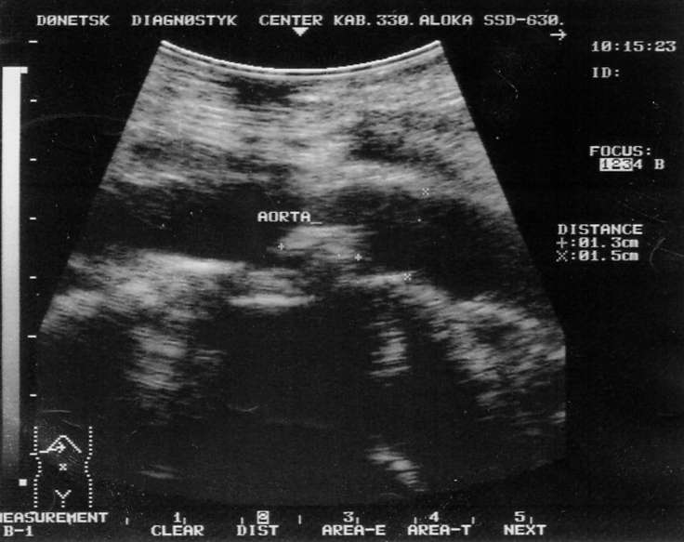 | b) 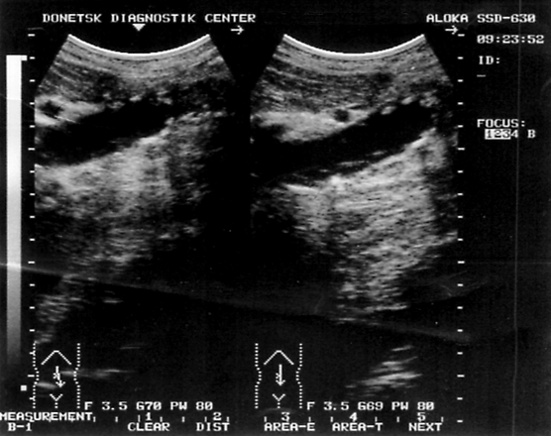
Fig. 1. Abdominal aorta sonographic samples of examined AIS patients.
a) Longitudinal scan of the abdominal aorta. On the back wall the formation of 1.5×1.3 cm is determined with increased echogenicity and indistinct contours ― fibrosing plaque of the abdominal aorta.
b) Longitudinal scan of the abdominal aorta. Unevenly thickened aortic walls due to a multitude of small (from 0.3 to 0.6 cm) formations of increased echogenicity, some of which contain calcifications (atherocalcinosis). The whole aortic lumen within the normal range.

a) 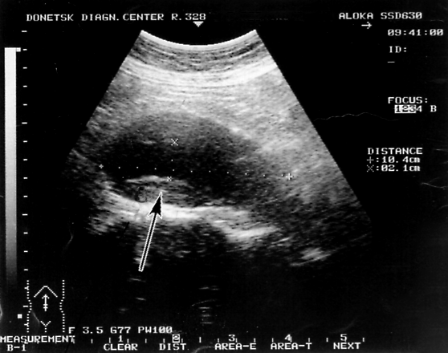 | b) 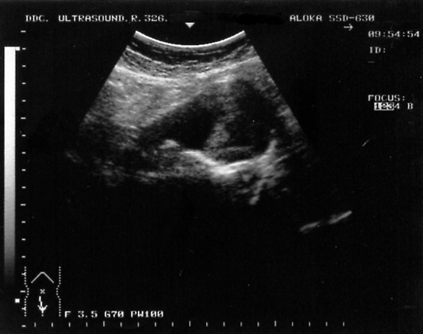
Fig. 2. Abdominal aorta sonographic samples of examined AIS patients.
a) Longitudinal scan of the abdominal aorta. In the mesogaster projection aneurysmal expansion of the abdominal aorta up to 6.0 cm in diameter is marked over 10.4 cm. Parietally visualized thrombotic mass (arrow). Diameter of free aortic lumen is 2.1 cm
b) Aneurysmal expansion of the abdominal aorta is determined. The diameters of the incoming and outgoing aorta within the normal range ― 1.6-1.8 cm. Aneurysm lumen is heterogeneous due to thrombotic overlays (masses).

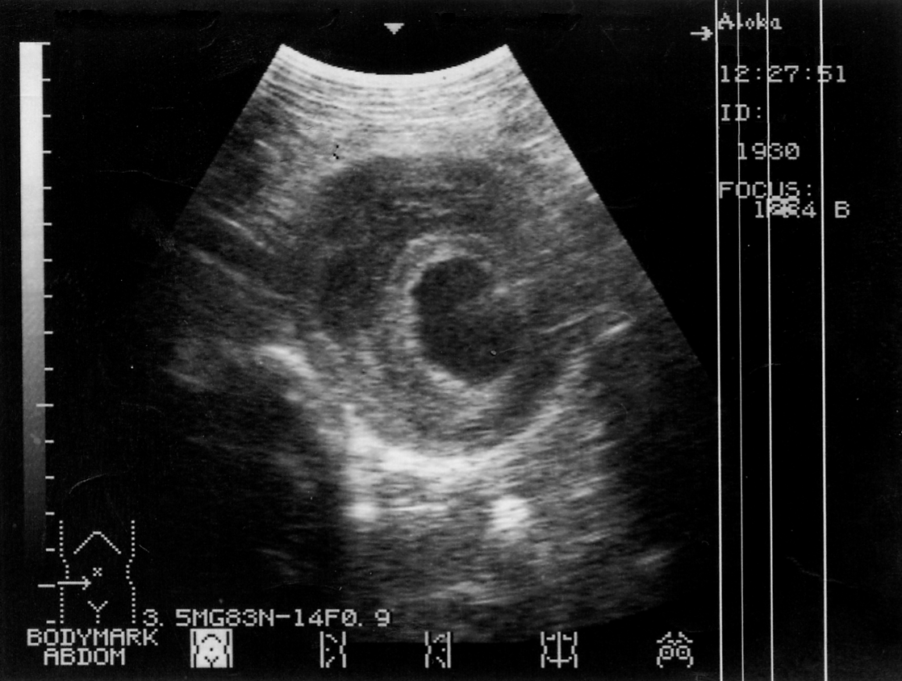
Fig. 3. Transverse scan of the abdominal aorta. Aortic diameter is expanded. Walls are thickened to 1.5 cm, have a layered structure due to stratification and bleeding (hematoma). Visible free aortic lumen is narrowed, homogeneous. Conclusion: laminated aneurysm of the abdominal aorta.
Ultrasonography of the liver in all the patients revealed its moderate increase, parenchymal heterogeneity, irregularly increased echogenicity. In 12 (20.0%) patients depletion of the vascular pattern of the liver was noticed. Ultrasound histogram index L in the right lobe of the liver was 31.2 ± 2.1 (healthy ― 18.6 ± 2.3; p<0.05), in the left liver lobe ― 30.8 ± 1.9 (healthy ― 19.0 ± 2.1; p<0.05). These data indicate that liver tissue is thickened, which in turn is due to organ fibrosis and, in some cases, steatosis. Both options are typical changes of liver upon AIS [20].
Frequency of sonographic symptoms of pancreatic lesions in the examined AIS patients is shown in Fig. 4.
As it can be seen from Fig. 4, sonographic signs of changes in the pancreas upon AIS are non-specific. Echogenicity and heterogeneity of the organ structure are the most frequent ones. Reduction in the size of the pancreas did not occur frequently (20.0%), but more frequently than the increase in organ size. It points out a greater frequency of atrophic processthan inflammatory one in the pancreas upon AIS. It should be noted that upon AIS calcifications of the pancreas are also found, although in practice the detection of such changes almost automatically diagnoses chronic pancreatitis, especially alcohol one. Fig. 5 represents as an example of a sonogram of the pancreas of one of our examined AIS patients, whose alcoholic etiology of the disease has been completely eliminated, while the presence of the pancreatic calcifications could be explained not only by ischemia.
Fig. 4. Frequency of sonographic symptoms of pancreatic lesions in the examined AIS patients.
1 — enlargement of the whole pancreas or its part; 2 — increased echogenicity; 3 — reduced echogenicity; 4 — structure heterogeneity; 5 — blurred contours; 6 — calcifications in pancreatic tissue; 7 — calcifications in pancreatic ducts; 8 — expansion of Wirsung’s duct; 9 — reduction of the pancreas; 10 — cysts and pseudocysts.

Due to the high frequency of increased echogenicity of pancreatic tissue ultrasound histogram index L was significantly increased to 36.9 ± 0.7 compared to the norm (17.3 ± 0.5; p<0.05). Homogeneity index N was reduced to 4.2 ± 0.2% (norm is 5.2 ± 0.4%; p<0.05). K_{gst} was also significantly reduced to 29.3 ± 3.5 (healthy 122.4 ± 12.3%; p<0.05).

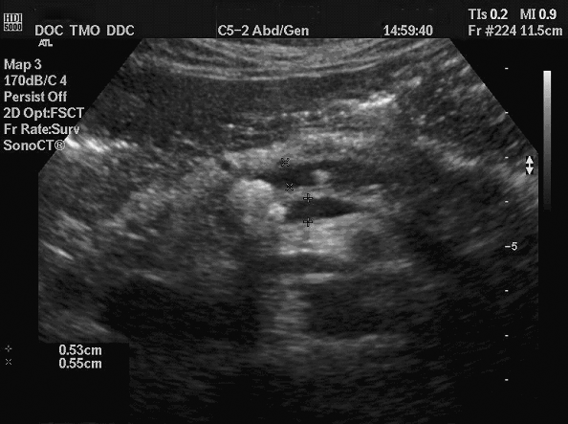
Fig. 5. Sonogram of patient V. with AIS. Pancreas is slightly increased in the head to 3.2 cm, wavy contours, heterogeneous structure. Increased echogenicity. In the projection of the head, body and Wirsung’s duct we defined hyperechoic oval structures that give an acoustic shadow. The largest size of these structures in the channel ― up to 0.7 cm; duct is expanded to 0.5 cm.

Sonography of abdominal aorta, liver, pancreas, ultrasonic histography was carried out before and after treatment. Unfortunately, esssential changes in ultrasound image, histograms indices were not identified. It points out significant morphological changes, which did not regress in the course of treatment.
Of course, Doppler ultrasound of the abdominal aorta, celiac trunk and superior mesenteric artery was both essential in AIS diagnostics, and in evaluating the results of treatment. The data obtained are presented in Table 1. When analyzing the Doppler indices before loading, it turned out that abdominal aorta PI (raised), superior mesenteric artery V_{ps} (reduced), superior mesenteric artery IR and PI (reduced) only differ from normal. Indices were significantly more informative after the glucose load: all these indicators (except abdominal aorta V_{ed}) differed significantly from that of healthy after the same load. Moreover, in AIS patients after load only celiac trunk and superior mesenteric artery V_{ed} were reduced as compared to healthy, while other parameters obtained after glucose load were significantly higher than in healthy (Table 1).
Table 1
Doppler ultrasound indices of the abdominal aorta, celiac trunk and superior mesenteric artery in AIS patients and healthy examined before and after glucose load
Indices | AIS patients, n=60 |  | Healthy, n=30
Indices | Before load | After load | Before load | After load
Abdominal aorta
V_{ps}, m/s | 0.89±0.04 | 1.39±0.03*/** | 0.94±0.05 | 1.25±0.04*
V_{ed}, m/s | 0.53±0.03 | 0.64±0.02* | 0.56±0.06 | 0.71±0.03*
IR | 1.20±0.04 | 1.31±0.03*/** | 1.15±0.09 | 0.91±0.04*
PI | 1.86±0.03** | 1.98±0.02*/** | 1.68±0.07 | 1.59±0.11
Celiac trunk
V_{ps}, m/s | 0.97±0.04 | 1.37±0.04*/** | 1.01±0.05 | 1.25±0.02*
V_{ed}, m/s | 0.25±0.02 | 0.36±0.02*/** | 0.30±0.03 | 0.49±0.01*
IR | 0.70±0.02 | 0.79±0.01*/** | 0.69±0.03 | 0.62±0.02
PI | 1.79±0.08 | 2.05±0.04*/** | 1.58±0.14 | 1.50±0.08
Superior mesenteric artery
V_{ps}, m/s | 0.86±0.06** | 1.25±0.04*/** | 1.01±0.04 | 1.08±0.03
V_{ed}, m/s | 0.21±0.02 | 0.30±0.02*/** | 0.17±0.02 | 0.43±0.05*
IR | 0.75±0.03** | 0.90±0.06*/** | 0.87±0.02 | 0.60±0.01*
PI | 1.77±0.15** | 2.58±0.21*/** | 2.19±0.12 | 1.34±0.18*
Note: * — indices before and after load are significantly different;
** — indices of patients and healthy before load or patients and healthy after load are significantly different.

We compared Doppler indices before and after loading. It turned out that load- influenced V_{ps} increases to a greater extent both in abdominal aorta, and in celiac trunk, and in the superior mesenteric artery, than in healthy persons. This indicates an increase in blood flow to the digestive organs upon AIS in terms of a smaller diameter and greater rigidity of the walls of the large vessels of the abdominal cavity. Due to glucose load, V_{ed} significantly increased in AISpatients, but evidentially lesser than in healthy. It may be explained by the diastolic velocity that is less affected by cardiac output, and more dependent on vascular tone than V_{ps}. Therefore, V_{ed} after load in AIS patients varies lesser than in healthy (Table 1).
IR in the abdominal aorta, celiac trunk and superior mesenteric artery upon AIS increased significantly after load. In healthy this figure was opposite: after load in the abdominal aorta and superior mesenteric artery it was significantly decreased, while it did not have significant direction to decrease in the celiac trunk, i.e. load-influenced IR dynamics may serve as a diagnostic criterion for AIS. PI has the same diagnostic value, being significantly increased after the load in all three vessels studied. After loading in healthy PI acquired direction to decrease in the abdominal aorta and celiac trunk, and significantly decreased in the superior mesenteric artery (Table 1).
Thus, increased IR and PI after load, more significant load-influenced V_{ps} growth than in healthy testifies to AIS diagnosis. Not so clear load-influenced V_{ed} growth has lesser value in AIS diagnosis than in healthy (Fig. 6).
Sample of interpretation of Doppler data is presented in Fig. 7.
Fig. 6. IR and PI dynamics in superior mesenteric artery before and after glucose load in patients and healthy.

a) 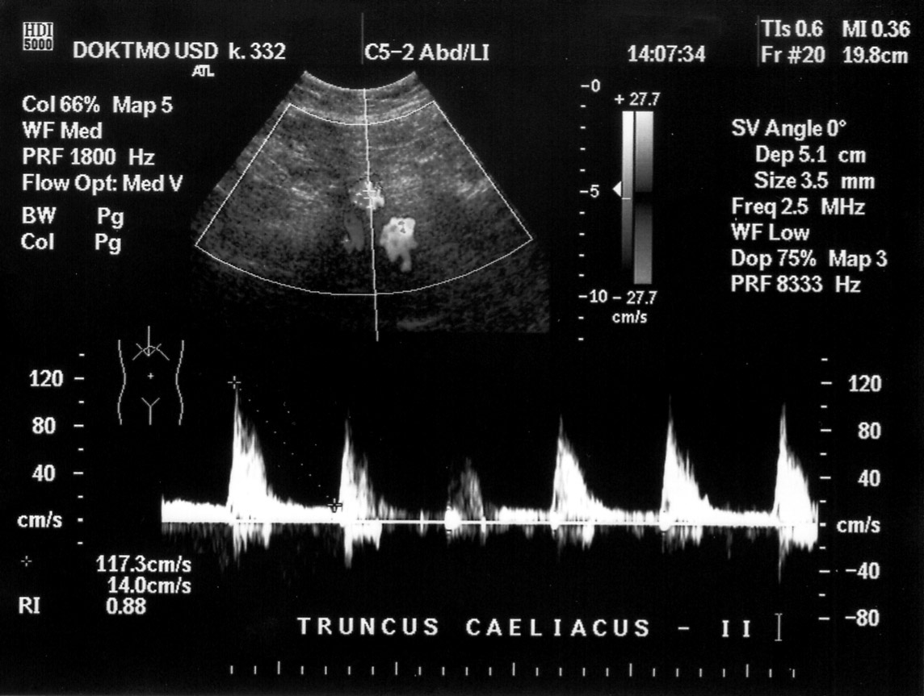 | b) 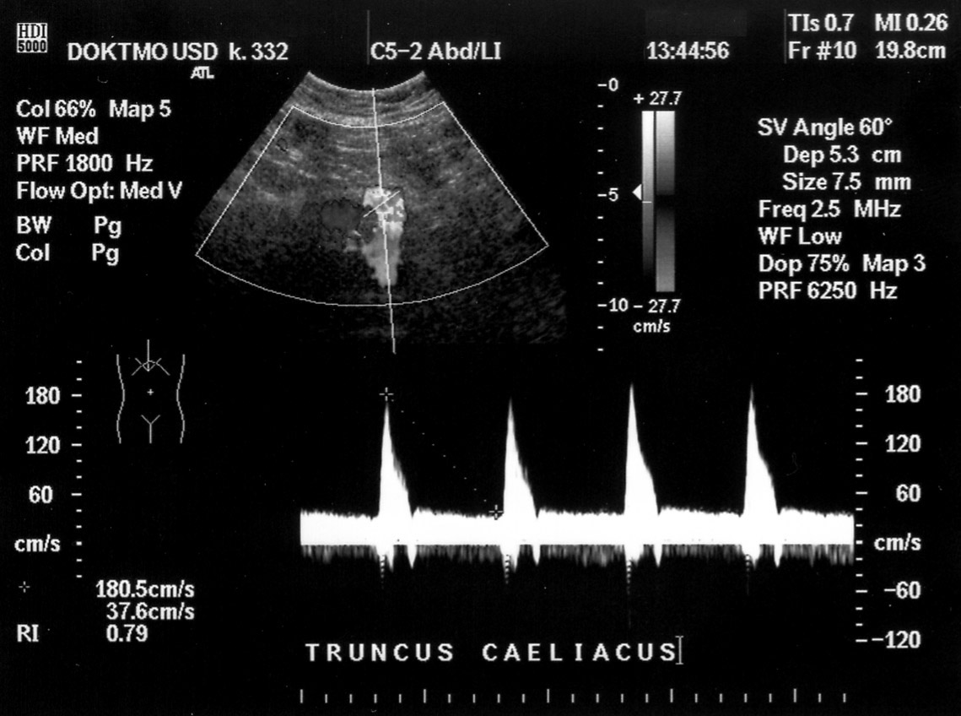
Fig. 7. Dopplerogram of AIS patient’s celiac trunk before (a) and (b) after glucose load.
a) V_{ps} — 1.81 m/s, V_{ed} — 0.38 m/s, RI — 0.79, PI — 1.22;
b) V_{ps} — 1.17 m/s, V_{ed} — 0.14 m/s, RI — 0.88, PI — 1.39.
After glucose load, instead of the expected V_{ps} and V_{ed} growth, their reduction is marked in patient, i.e. response to food stimulation was inadequate and conditions of blood flow in the celiac trunk after load sharply worsened. In addition, RI and PI rise characteristic for AIS was registered after load.

Significant V_{ps} and PI increase in the superior mesenteric artery before the load was reached in the treatment of AIS patients with combination of Essentiale H and Glutargin. Thus, V_{ps} increased from 0.86 ± 0.06 m/s to 1.02 ± 0.02 m/s (p<0.05), and PI increased from 1.77 ± 0.15 to 2.08 ± 0.03 (p<0.05). Significant RI decrease in all three vessels studied after load was a remarkable result of the treatment. So, IR in the abdominal aorta after load dropped from 1.31 ± 0.03 to 0.96 ± 0.02 (p<0.05), in the celiac trunk ― from 0.79 ± 0.01 to 0.65 ± 0.03 (p<0.05), in the superior mesenteric artery ― from 0.90 ± 0.06 to 0.65 ± 0.02 (p<0.05). Probably, due to IR decrease rate, V_{ps} decreased after load in the abdominal aorta from 1.39 ± 0.03 m/s to 1.23 ± 0.01 m/s (p<0.05) and in the superior mesenteric artery ― from 1.25 ± 0.04 m/s to 1.12 ± 0.03 m/s (p<0.05). In the celiac trunk this figure, as well as other Doppler data in AIS patients, changed insignificantly under the influence of treatment.
Any patient noted side effects during treatment. Results of treatment were evaluated as "excellent" by 28 (46.7%) patients, as "good" ― by 17 (28.3%) patients, as "satisfactory" ― by 13 (21.7%) patients and only 2 (3.3 %) patients did not report any improvement from treatment. The latter patients were detected to have abdominal aortic aneurysm.
Conclusions.
- Sonography of the abdominal aorta can serve as a screening method in AIS diagnostics. Changes, which can be detected by ultrasound of the liver and pancreas, are non-specific and inert, i.e. significant dynamics under the influence of treatment is not observed.
- During combined AIS treatment with the inclusion of Essentiale H and Glutargin blood flow improvement is achieved in the abdominal aorta, celiac trunk and superior mesenteric artery according to Doppler data.
Prospects of study are to investigate the effect of Essentiale H and Glutargin combination on clinical symptoms, functional state of the liver and pancreas, quality of life in patients with AIS.

References
- Абулов М. Х. Клинические варианты хронической абдоминальной ишемии при мезентериальном атеросклерозе / М. Х. Абулов, В. В. Мурашко // Тер. архив. — 1986. — № 11. — С. 119–122.
- Бабак О. Я. Глутаргин — фармакологическое действие и клиническое применение / О. Я. Бабак, В. М. Фролов, Н. В. Харченко. — Харьков, Луганск : ЭЛТОН-2, 2005. — 456 с.
- Бабак О. Я. Хронические гепатиты / О. Я. Бабак. — Киев : Блиц-Информ, 1999. — 208 с.
- Богер М. М. Методы исследования поджелудочной железы / М. М. Богер. — Новосибирск : Наука, 1982. — 240 с.
- Болезни печени и желчевыводящих путей / Под. ред. В. Т. Ивашкина. — М. : М-Вести, 2002. — 416 с.
- Буеверов А. О. Место гепатопротекторов в лечении заболеваний печени / А. О. Буеверов // Болезни органов пищеварения. — 2001. — № 1. — С. 16–18.
- Буеверов А. О. Некоторые патогенетические и клинические вопросы неалкогольного стеатогепатита / А. О. Буеверов, М. В. Маевская // Клин. перспективы гастроэнтерологии, гепатологии. — 2003. — № 3. — С. 2–7.
- Гепатопротекторы-антиоксиданты в терапии больных с хорническими диффузными заболеваниями печени / И. И. Дегтярева, И. Н. Скрыпник, А. В. Невойт [и др.] // Новые мед. технологии. — 2002. — № 6. — С. 18–23.
- Губергриц Н. Б. Клиническая панкреатология / Н. Б. Губергриц, Т. Н. Христич. — Донецк : Лебедь, 2000. — 416 с.
- Гундерманн К.-Й. Новейшие данные о механизмах действия и клинической эффективности эссенциальных фосфолипидов / К.-Й. Гундерманн // Клин. перспективы гастроэнтерологии, гепатологии. — 2002. — № 2. — С. 21–24.
- Гуревич К. Г. Эссенциальные фосфолипиды в лечении заболеваний печени / К. Г. Гуревич // Качеств. клин. практика. — 2002. — № 4. — С. 1–4.
- Ігнатов В. А. Патогенетичне значення прозапальних і профіброгенних цитокинів у формуванні фіброзувальних реакцій при хронічних гепатитах : Автореф. дис. … канд. мед. наук (14.01.02) / В. А. Ігнатов. — Луганськ, 2002. — 19 с.
- Дмитриева И. В. Особенности гемодинамики непарных ветвей брюшной аорты, вызывающие ишемию поджелудочной железы / И. В. Дмитриева // Рос. гастроэнтерол. журн. — 1997. — № 3. — С. 35–38.
- Ивашкин В. Т. Антифибротическая терапия: настоящее и будущее / В. Т. Ивашкин // Материалы симпозиума «Фиброз печени». — М., 2004. — С. 17–22.
- Ишемическая болезнь кишок / М. Б. Коломойская, Е. А. Дикштейн, В. А. Михайличенко, Н. М. Ровенская. — Киев : Здоров’я, 1986. — 132 с.
- Калинин А. В. Хронический абдоминальный ишемический синдром. Особенности клиники и диагностики / А. В. Калинин, Д. К. Степуро, Г. М. Токмулина // Рос. журн. гастроэнтерологии, гепатологии, колопроктологии. — 2003. — Прил. № 21. Материалы IX Российской гастроэнтерологической Недели, М., 2003. — С. 52.
- Калинин А. В. Хронический панкреатит // Клинические лекции по гастроэнтерологии и гепатологии / Под ред. А. В. Калинина, А. И. Хазанова. — М., 2002. — Т. 2. — С. 265–297.
- Клинико-патогенетическая оценка информативности и современные возможности оптимизации ультразвуковой диагностики хронического рецидивирующего панкреатита / Н. Б. Губергриц, Н. Е. Баринова, В. В. Беляев [и др.] // Мед. визуализация. — 2002. — № 1. — С. 48–58.
- Пат. 59742 А України, МПК7 A61B10/00, A61B5/02.Спосіб діагностики атеросклеротичного ураження мезентеріальних артерій / М. Ю. Коломієць, Н. І. Бурмістр, Є. П. Ткач. — № 20021210024 ; заявл. 12.12.02 ; опубл. 15.09.03, Бюл. № 9.
- Лазебник Л. Б. Хроническая ишемическая болезнь органов пищеварения / Л. Б. Лазебник, Л. А. Звенигородская. — М. : Анахарсис, 2003. — 136 с.
- Лелюк В. Г. Методика ультразвукового исследования сосудистой системы: технология сканирования, нормативные показатели : метод. пособие / В. Г. Лелюк, С. Э. Лелюк. — М. : Б. и., 2002. — 39 с.
- Логинов А. С. Болезни кишечника / А. С. Логинов, А. И. Парфенов. — М. : Медицина, 2000. — 632 с.
- Лэпедат П. Инфаркт кишечника / П. Лэпедат. — Бухарест : Б. и., 1975. — 280 с.
- Меркулова Ю. В. Фармакологические исследования препарата Глутаргин / Ю. В. Меркулова, О. Н. Гомон, Л. А. Чайка // Збірник робіт науково-практичної конференції „Глутаргін — нові принципи фармакотерапії захворювань печінки”. — Харків, 2003. — С. 7–10.
- Нарушения микроциркуляции при хронической ишемической болезни органов пищеварения и дислипопротеидемии / В. С. Савельев, В. А. Петухов, С. Г. Бычков [и др.] // Груд. и сердеч.-сосудистая хирургия. — 1999. — № 4. — С. 40–45.
- Нидерау К. Эссенциальные фосфолипиды в лечении хронических вирусных гепатитов В и С / К. Нидерау // Укр. мед. часопис. — 1998. — № 3. — С. 81–82.
- Ойноткинова О. Ш. Атеросклероз и абдоминальная ишемическая болезнь / О. Ш. Ойноткинова, Ю. В. Немытин. — М. : Медицина, 2001. — 312 с.
- Ойноткинова О. Ш. Диагностические критерии хронической абдоминальной ишемии у больных ишемической болезнью сердца / О. Ш. Ойноткинова // Материалы XXII научной конференции. — М., 1990. — Ч. 1. — С. 173–174.
- Парфенов А. И. Энтерология / А. И. Парфенов. — М. : Триада-Х, 2002. — 744 с.
- Подымова С. Д. Механизмы алкогольных повреждений печени и их фармакологическая коррекция эссенциальными фосфолипидами / С. Д. Подымова // Материалы конференции «Алкогольная болезнь печени. Пути фармакологической коррекции». — М., 1999. — С. 1−6.
- Покровский А. В. Диагностика и хирургическое лечение синдрома хронической абдоминальной ишемии : метод. рекомендации / А. В. Покровский, П. О. Казанчан. — М., 1980. — 25 с.
- Савельев В. С. Холестероз желчного пузыря / В. С. Савельев, В. А. Петухов, Б. В. Болдин. — М. : ВЕДИ, 2002. — 192 с.
- Сучасна фармакотерапія хронічних гепатитів : метод. рекомендації / МОЗ України, Укр. центр наук.-метод. інформ. та патент.-ліценз. роботи ; Авт. : О. Я. Бабак [та ін.]. — Харків : Б. в., 1997. — 16 с.
- Хронический абдоминальный ишемический синдром и сочетанные с ним заболевания: особенности клиники, диагностики и лечения / А. В. Калинин, Д. К. Степуро, Н. В. Корнеев [и др.] // Клин. перспективы гастроэнтерологии, гепатологии. — 2003. — № 6. — С. 19–23.
- Endovascular treatment of chronic mesenteric ischemia: report of five cases / U. Nyman, K. Ivancev, M. Lindh, P. Uher // Cardiovasc. Intervent. Radiol. — 1998. — Vol. 21, No 4. — P. 305–313.
- Gardell S. J. Ticlopidine and clopidogrel: antithrombotic agents that block ADP-mediated platelet activation / S. J. Gardell // Perspect. Drug. Des. — 1993. — Vol. 3. — P. 521–526.
- Marston A. Diagnosis and management of intestinal ischemia / A. Marston // Ann. R. Col. Surg. Engl. — 1972. — Vol. 50. — P.29–44.
- Niederau C. Polyunsaturated phosphatidyl-choline and interferon alpha for treatment of chronic hepatitis B and C : multi-center, randomized, double-blind, placebo-controlled trial / C. Niederau, G. Strohmeyer, T. Heinges // Hepatogastroenterology. — 1998. — Vol. 45. — P. 797–804.
- The Pancreas / Ed. H. G. Beger [et al.]. — Oxford [et al.] : Blackwell Science Ltd., 1998. — Vol. 1. — P. 264–271.

Clinical and pathogenetic substantiation of effectiveness of Essentialle N and Glutargin combination in treatment of chronic abdominal ischemic syndrome
N. B. Gubergrits, N. G. Agapova, L. I. Shkarbun
Donetsk National Medical University n. a. M. Gorky, Ukraine

Key words: abdominal ischemic syndrome, sonography of abdominal aorta, liver and pancreas, Doppler ultrasonography, Essentialle N, Glutargin
The article presents a detailed literature review regarding etiology, pathogenesis, diagnostics, clinical picture and management of abdominal ischemic syndrome and pathogenetic substantiation of its treatment with combination of Essentialle N and Glutargin. Authors explicitly studied an influence of such treatment on sonographic changes of abdominal aorta and its branches and on dopplerographic indices. It was shown, that under influence of the treatment a significant improvement of Doppler ultrasonography indices of aorta, celiac trunk and superior mesenteric artery were achieved.

